**2.Program to find even and odd numbers**

**from a given list:**

**CODE :**

.model small

.stack 100h

.data

ev db 'Even$'

od db 'Odd$'

.code

main proc

mov ax,@data

mov ds,ax

mov ah,1

int 21h

mov bl,2

div bl

cmp ah,0

je IsEven

mov dx,10

mov ah,2

int 21h

mov dx,offset od

mov ah,9

int 21h

mov ah,4ch

int 21h

IsEven:

mov dx,10

mov ah,2

int 21h

mov dx,13

mov ah,2

int 21h

mov dx,offset ev

mov ah,9

int 21h

mov ah,4ch

int 21h

main endp

end main

**Execution Of ASM File:**

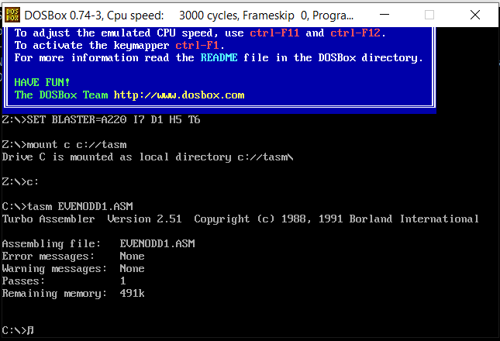

**Initial Output Window:**

